A

REPORT

ON THE STUDY

CARRIED OUT ON

COASTAL ECOSYSTEM CONSERVATION AND FISH PRODUCTION FOR LIVELIHOOD SUPPORT IN SOUTHWEST, NIGERIA

SUBMITTED BY: DR A.I. IKILILU

SEPTEMBER, 2021

INTRODUCTION

Nigeria is home to Africa’s largest economy and population. The country is endowed with abundant natural resources. It also has abundant oil and natural gas reserves, abundant water and one of the largest mangrove ecosystems in Africa. The coastal zone stretches along 853 km exclusive economic zone (EEZ), which is crucial to the country’s economy activities which includes; oil and gas exploration, fishing, shipping, and agriculture.

Lagos state is said to contribute significantly to the country’s economy. Hence, the need to embark on the study to develop the livelihood of fisherfolks in the state. The study is been carried out at Badagry and Ibeju- Lekki axis of the state. The choice of the location is based on the fact that they lie on the coast of the state and numerous activities are been carried out in the region

* 1. **IBEJU-LEKKI**

This part of Lagos state is witnessing significant developmental activities in-terms of housing, construction of deep sea port and also refinery. It is also the area designed for Lagos free trade because of its proximity to the Atlantic ocean.

Ibeju lekki is under Ibeju-Lekki local government authotity. It has numerous landing site along the ocean bed.

We were received by the President of the Lagos state Fishermen Cooperative association in the person of Hon. A.A. Atobajeun, who told us about the various landing sites include:

* Imagbon Alade
* Orimedu
* Orofun
* Akodo
* Tiye
* Mobido
* Idasho
* Itokin
* Imagbon Sagun
* Leje

The fish popular with this region includes:

* Sawa
* Crayfish
* Sayaganga
* White snapper
* Red snapper
* Bonga

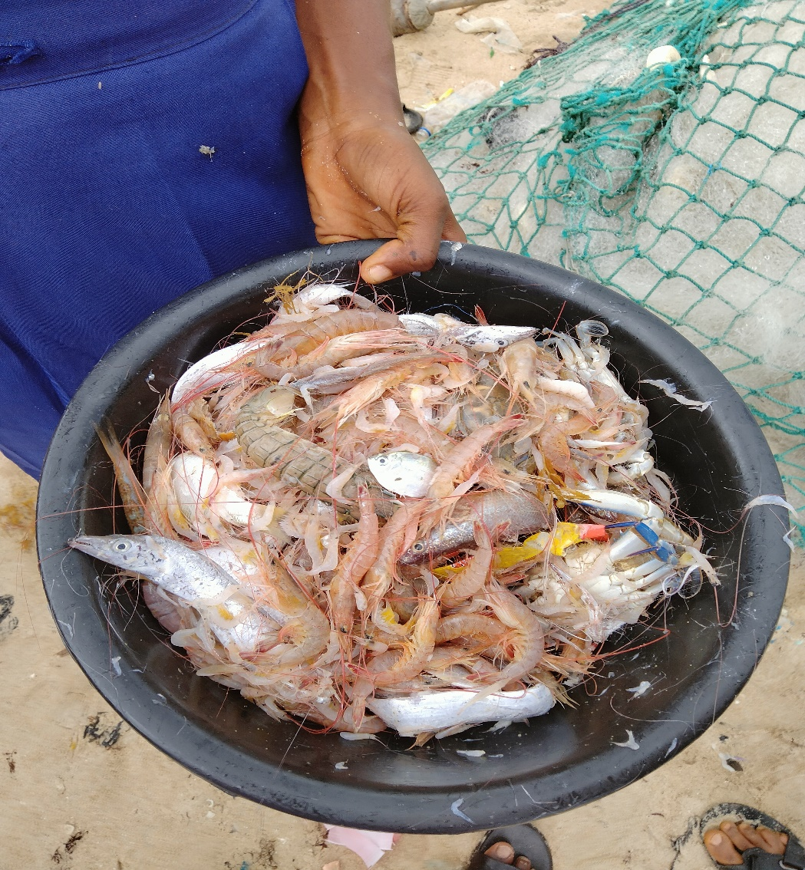

Plate 1: Some of the catches

There fishing activites are characterized by using gillnet, siene net, beach siene net, used on a canoe with mostly 40hp to fish on the water body. Imagbon Alade, Akodo, Orofun and Orimedu were visited because other landing sites are been hampered by the presence of the construction of the refinery going on.

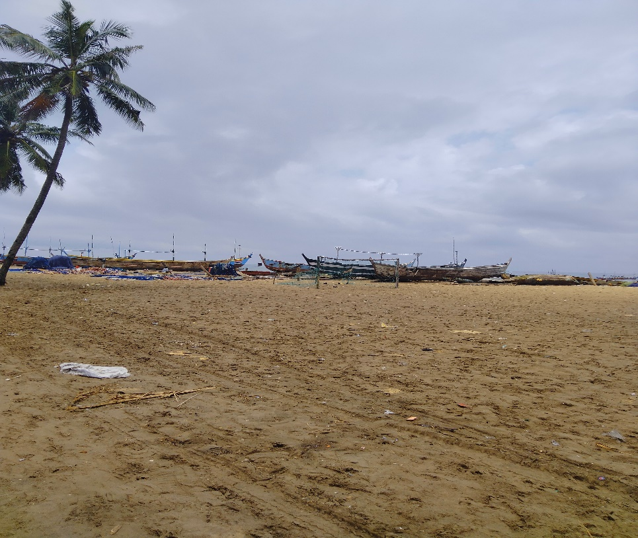

Plate 2: Canoe getting ready to sail

The fisherfolks were unwilling to cooperate due to the constant visitation of people who have promised so much but have done little or nothing towards their promises. Activites at this landing sites where minimal as the ocean level as increased in level which hinders navigation and also the capture of fishes in the water body.

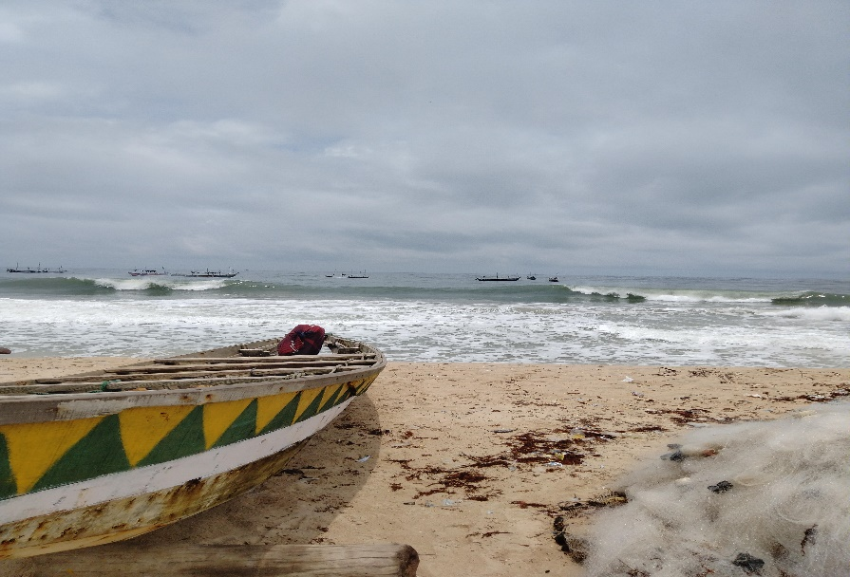

Plate 3: Canoe waiting for tides to calm

Fisher folks have witnessed pollution on the water body as they attributed it to the activities going on the refinery in the region as their catches have been reduced in recent times. Also they lose their fishing gears due to the underlay pipe at the bottom of the ocean as most where not properly buried or are forgotten. The fishermen uses upto 10-13 bundles of mono filament for a fishing operation.

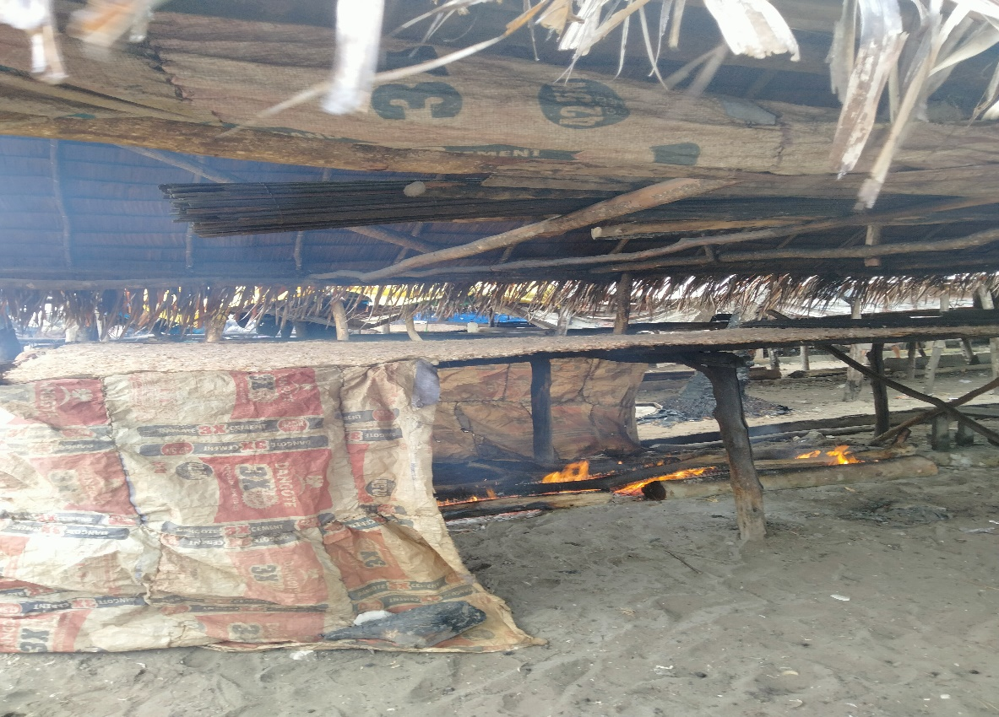

Plate 4: Crayfish smoking

Crayfish is more abundant in this region as every household as a designed space for the operation and it is done in large quantity.

Some of the fisher men agree on what ever conservation system the government adopts but of the opininon that the government won’t see to its effectiveness as been practiced in neighbouring country Ghana.

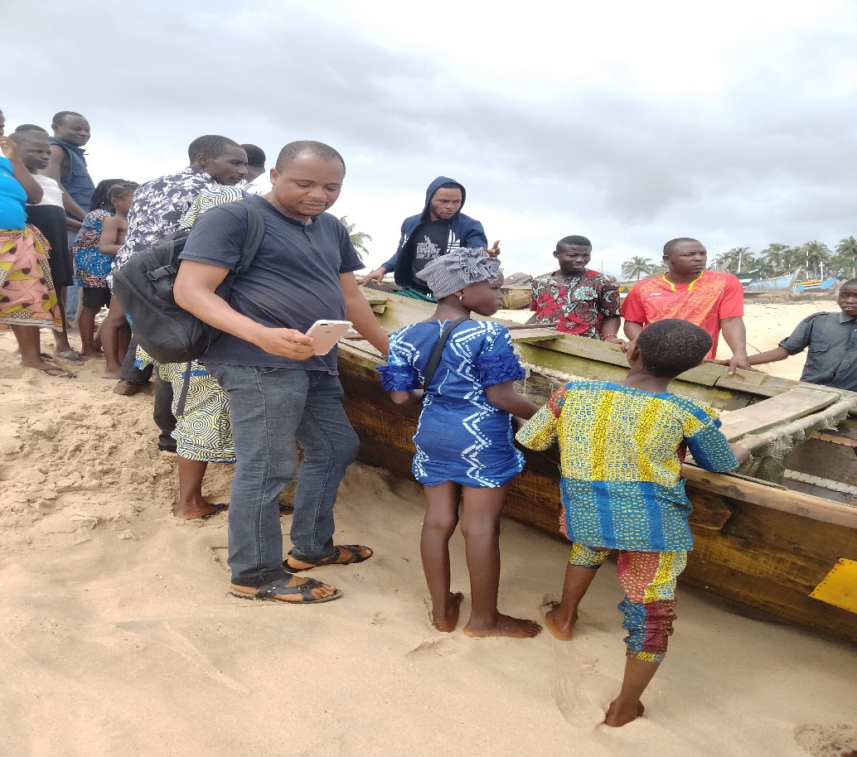

Plate 5: Assisting in landing a canoe

High cost of outboard engine and fishing net as made most fishermen leave the venture.

* 1. **BADAGRY**

This is also a coastal region in Lagos state. It is under the Badagry west local government. Badagry is bounded by fresh water and marine water.

We were received by the deputy director of fisheries Mr Apari at the ministry. He showed us the present project going on in the region by the Lagos state Appeal Project, which is located at Afowo. This project is a cage culture with over 400 cages of 8ftx4ftx4ft dimension and each cage containing 4000 fishes.

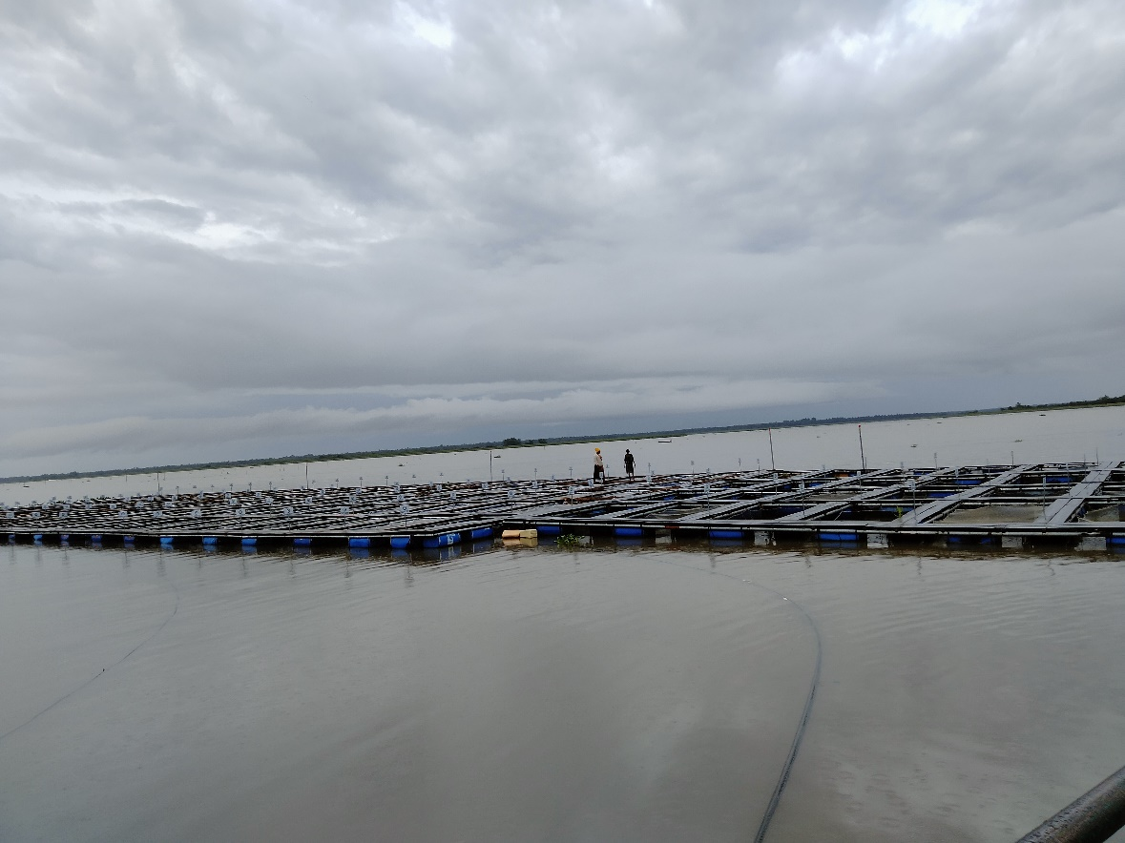

Plate 6: Arrangement of cages on water

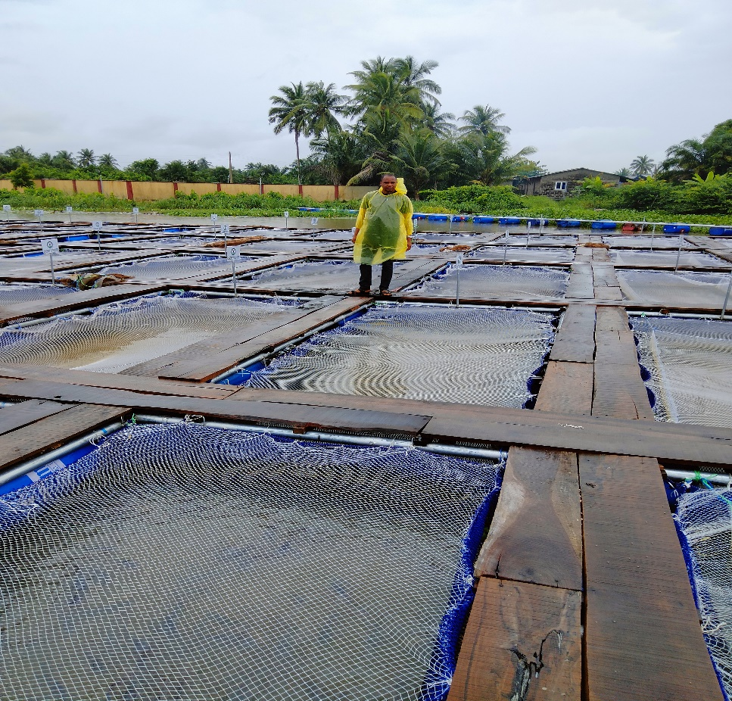

Plate 7: Cage culture on the fresh water in badagry

Mr Apari later took us to meet the president of Lagos state fishermen cooperative association in the person of Baba Agba.

Fishing operation in badagry is majorly characterized by the Egun/Awori tribe and supported by Ghanians, Togolese and whatever ever man power they could get. They believe the Ghanian are the best and their fishing crafts is been designed and repaired by them.

They use hired labour in this part of the coast and do not engage in crayfish harvesting. The landing sites include:

* Tokunbo/Akoro
* Gbethrome
* Asipa
* Kotopa-Yeboyan
* Misio weylao

The landing sites is been called after family name has been observed.

Major fish been caught include:

* Croacker fish
* Nig. Mackerel
* Grouper
* Silver catfish
* Barracuda
* Clarias
* Cynoglossus

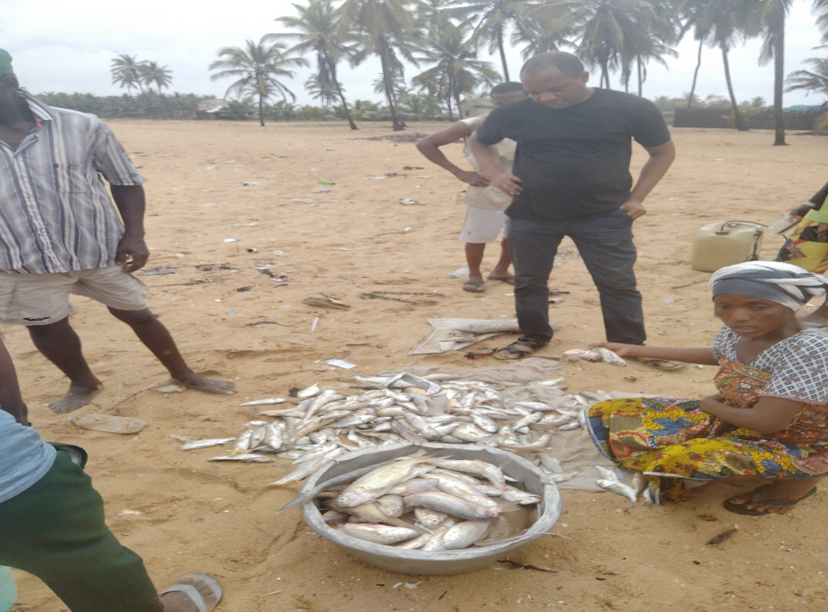

Plate 8: Some of the catches

Also, a brief purpose of our presence was held by the presence of the president, who beckoned on all members to listen to what we have to say.

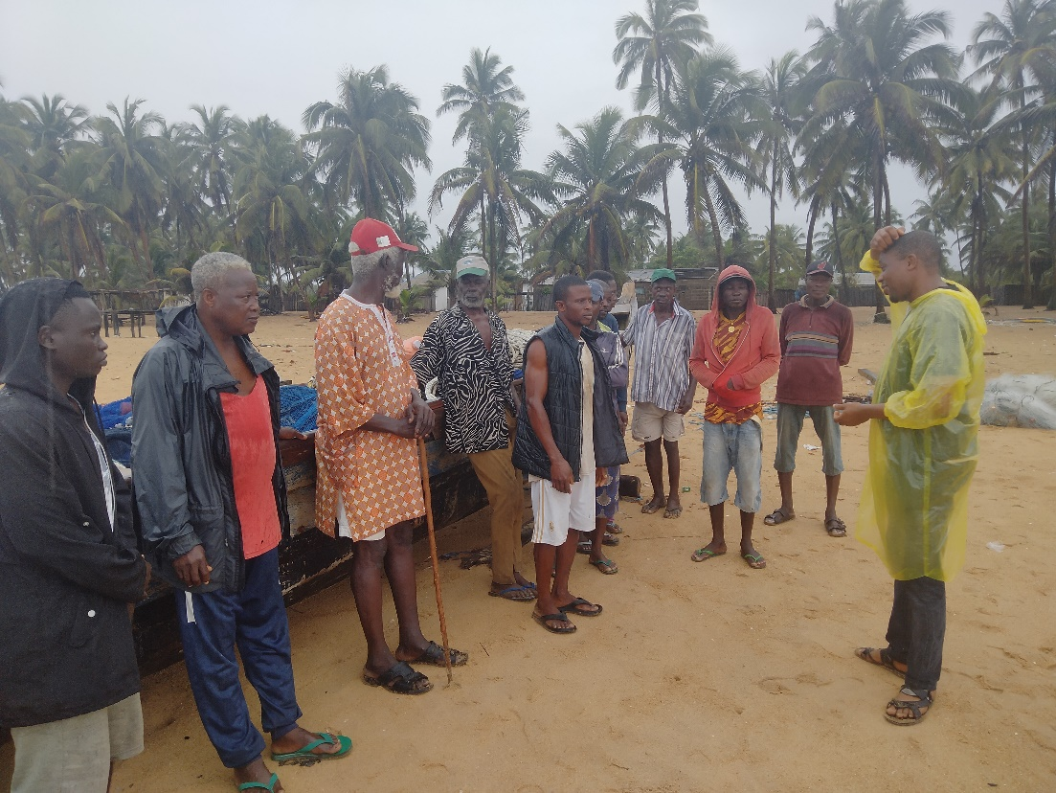

Plate 9: Focus group in progress